WEDE5020 ST10476147

group 1

kamohelo mosia

2025

 Proposal to Enhance Elite Euro Auto Service’s Growth through a Customized Website

**1. Organisation Overview**

* **Name**: Elite Euro Auto Services
* **Brief History**: Founded in 2015 in Sydney, Elite Euro Auto Services is an independent European vehicle repair workshop specialising in luxury and performance vehicles. The business was started by a team of certified European car technicians who saw a gap in affordable, high-quality care for European car owners outside the dealership network.
* **Mission**: To deliver dealership-level expertise and diagnostics for European vehicles, at a more competitive price with personalised customer service.
* **Vision**: To be Sydney’s most trusted and respected independent European vehicle service centre.
* **Target Audience**: Owners of high-end European vehicles such as BMW, Audi, Mercedes-Benz, Volkswagen, Volvo, and Porsche. Customers are typically professionals aged 30–60 who value performance, precision, and high-quality care for their vehicles.

**2. Website Goals and Objectives**

* Establish an online presence with a premium and professional aesthetic.
* Provide detailed information about services for different European brands.
* Allow customers to **book service appointments online**.
* Build trust through customer testimonials and technician profiles.
* Educate customers about preventative maintenance and vehicle care.

**Key Performance Indicators (KPIs):**

* Increase service bookings by 25% in 3 months.
* Decrease phone call bookings by 40% (shift to online).
* Achieve bounce rate below 35% by improving navigation and speed.

**3. Current Website Analysis *(Hypothetical)***

* **Strengths**: Brand domain secured, basic contact details available.
* **Weaknesses**: Outdated look, no mobile optimisation, no service booking system, poor SEO.
* **Improvements Needed**:
  + Responsive design
  + Integrated booking form with calendar
  + Better service categorisation (by car make)

**4. Proposed Website Features and Functionality**

* **Homepage**: Eye-catching hero image with call to action ("Book Your Euro Car Service Today")
* **Brands We Service**: Sections for BMW, Audi, Mercedes-Benz, etc., with details
* **Services Page**: Diagnostics, logbook servicing, performance tuning, aircon repairs
* **About Us**: Business story, team profiles with certifications
* **Booking Page**: Integrated form with preferred time/date picker
* **Testimonials**: Carousel or card format
* **Blog/Resources**: Maintenance tips, industry updates
* **Contact Page**: Google Maps embed, business hours, phone, WhatsApp link

**5. Design and User Experience**

* **Colour Scheme**: Dark blue, metallic silver, and white (evoking trust, precision, professionalism)
* **Typography**:
  + Headings: **Montserrat** (modern and bold)
  + Body Text: **Open Sans** (clean, readable)
* **Layout**:
  + Hero image > Key services > Car brands > Testimonials > Footer
  + Sticky header navigation
  + Strong use of iconography and vehicle imagery
* **UX Considerations**:
  + Mobile-first design
  + Easy booking from every page
  + Speed-optimised and SEO-friendly

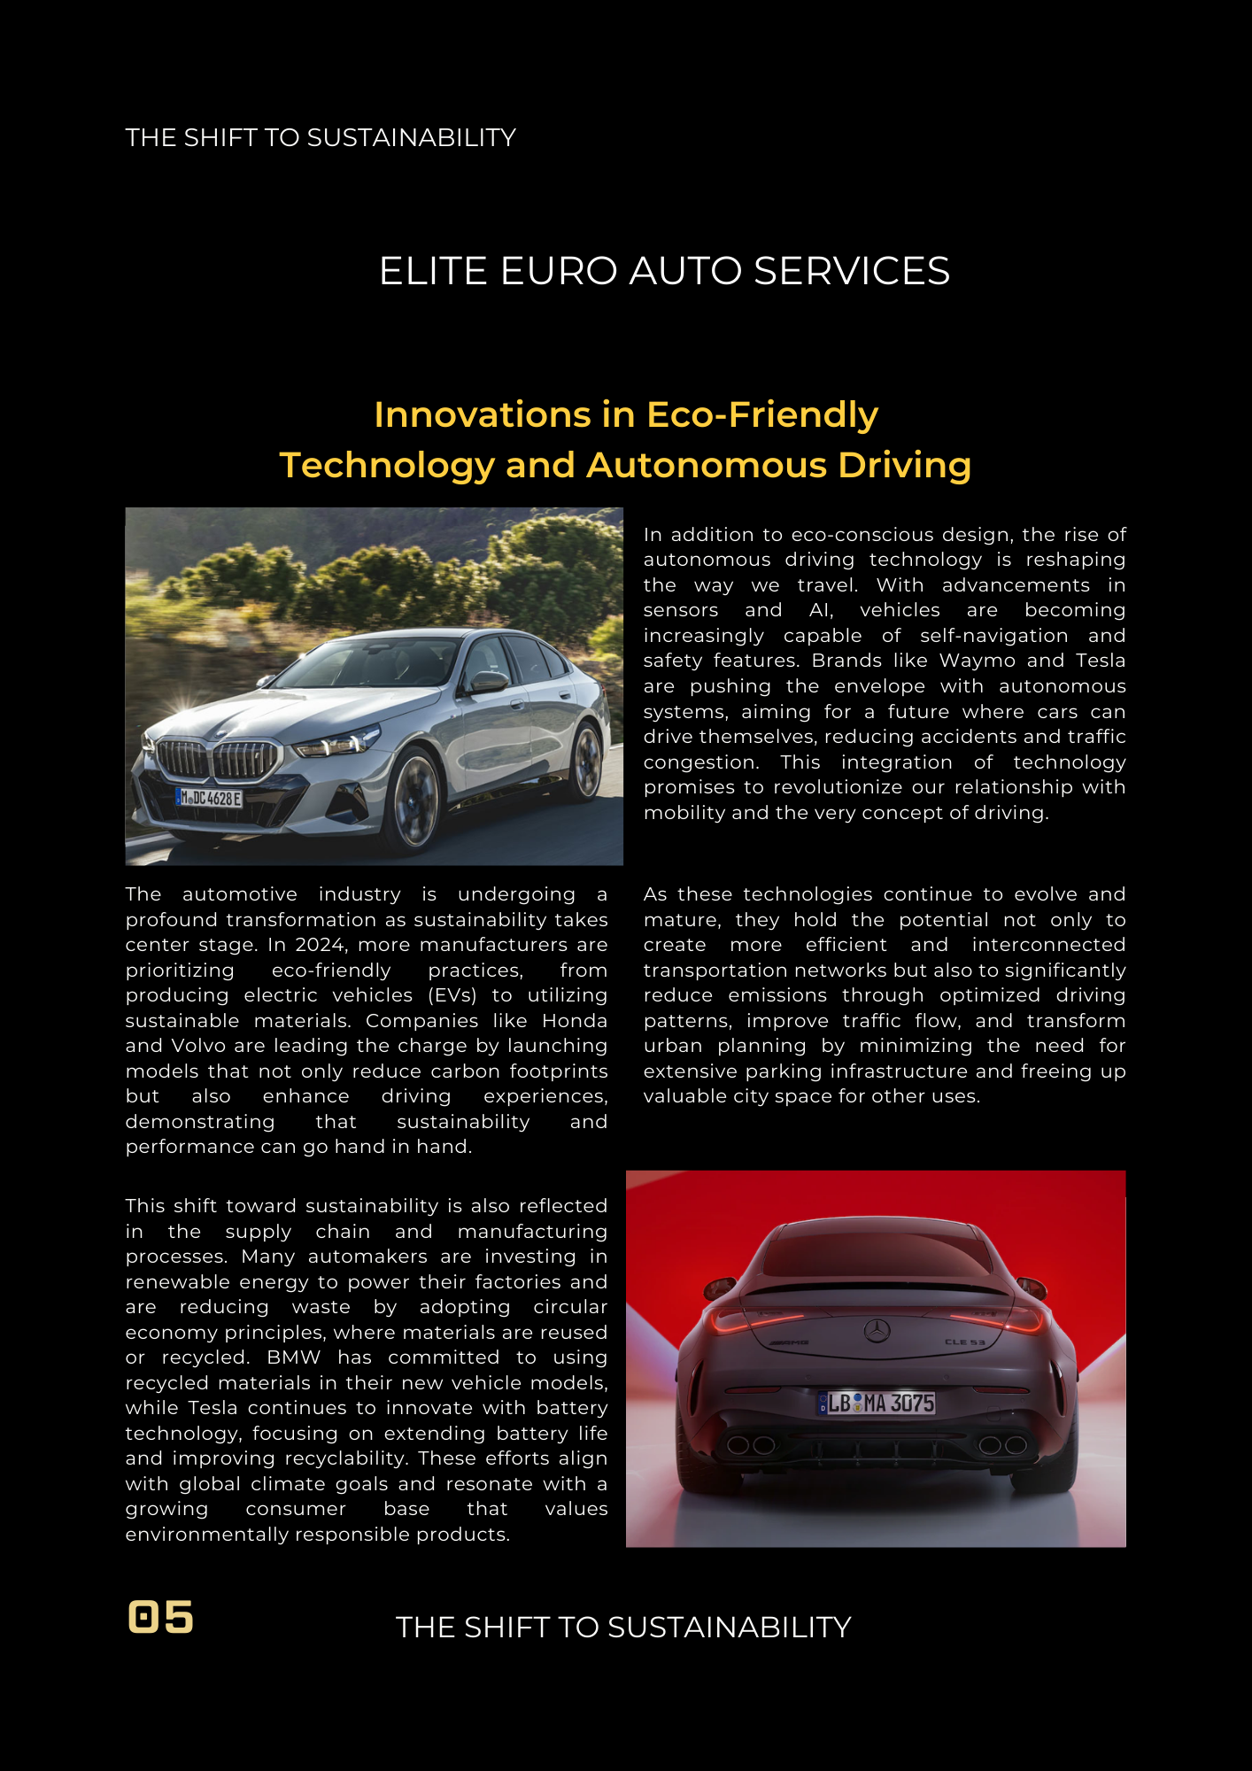

(Canva, 2025)

**6. Technical Requirements**

* **Domain**: www.eliteeuroautoservices.com.au
* **Hosting**: Site Ground or GoDaddy Business Hosting
* **Languages/Frameworks**: HTML5, CSS3, JavaScript (Vanilla or React for interactivity), PHP (for backend form processing)
* **CMS**: WordPress (for blog and CMS-friendly updates) or fully custom static site

**7. Timeline and Milestones**

| **Task** | **Deadline** |
| --- | --- |
| Initial Research & Wireframes | Aug 20 |
| UI Design Mockups | Aug 25 |
| Development Start | Sep 1 |
| Core Pages Built | Sep 10 |
| Booking System Integrated | Sep 15 |
| Testing & Revisions | Sep 20 |
| Final Launch | Sep 27 |

**8. Budget Estimate**

| **Item** | **Cost (AUD)** |
| --- | --- |
| Domain Name | $25/year |
| Hosting | $120/year |
| Booking Plugin/Dev | $60 (or custom build) |
| SSL Certificate | Included with hosting |
| Total Estimate | ~$205 initial year |

**9. References**

Available at:https://www.canva.com/design/DAGwco6KM_U/qcU1n0mDcPtFmUyNqV8mow/view?utm_content=DAGwco6KM_U&utm_campaign=designshare&utm_medium=link2&utm_source=uniquelinks&utlId=h2b80afb004 [Accessed 18 Aug 2025].

Collective, U., 2023. *UX Design Tips for Auto Service Websites..* [Online]   
Available at: https://uxde <https://www.canva.com/design/DAGwco6KM_U/qcU1n0mDcPtFmUyNqV8mow/view?utm_content=DAGwco6KM_U&utm_campaign=designshare&utm_medium=link2&utm_source=uniquelinks&utlId=h2b80afb004sign.cc> [Accessed 18 aug 2025].

Help, G. B. P., 2024. *Best Practices for Local Businesses Online..* [Online]   
Available at: <https://support.google.com/business/> [Accessed 18 aug 2025].